|  |  |  |
| --- | --- | --- |
| **Social Connect and Responsibility Report-3** | | |
| **Department: CSE(DATA SCIENCE)** | | **Course Code:22SCK47** |
| **Semester: IV** | **Section: A** | **Group No: 3** |
| **Student Name: Ashlin Alex** | | **USN: 1NH23CD022** |
| **Faculty Mentors: Ms SWATI SEHGAL** | | |
| **Module 3: ORGANIC FARMING AND WASTE MANAGEMENT** | | |
| **Activity Planned:**  **To visit Swachagraha Kalika Kendra** | | |
| **Location of activity execution:**  **WJ8Q+3H4, 14th A Cross Rd, Sector 4, HSR Layout, Bengaluru, Karnataka 560102** | | |
| **Date and timings of execution:** | | |
| **Summary of Activity: minimum 500 words ORGANIC FARMING:**  **Introduction:** Organic farming is an eco-friendly and sustainable approach to agriculture that emphasizes the use of natural processes, biodiversity, and ecological balance to cultivate crops and food. Unlike conventional farming, it avoids the use of synthetic fertilizers, pesticides, and genetically modified organisms (GMOs). Instead, it relies on methods like crop rotation, composting, mulching, biological pest control, and the use of bio-fertilizers. This farming practice not only nourishes and revitalizes the soil but also minimizes environmental degradation, promotes ecological harmony, and supports the well-being of farming communities.  **Objectives:**   * To understand how natural resources such as compost, bio-fertilizers, and organic pest control alternatives are used in place of harmful synthetic chemicals. * To observe sustainable farming methods that safeguard soil health and encourage biodiversity. * To spread awareness about the environmental, economic, and health-related advantages of organic farming. * To explore the feasibility of adopting small-scale organic farming initiatives within the campus environment.   **Visit:** As part of an educational initiative, we visited **Swachagraha Kalika Kendra**, a center dedicated to promoting sustainable farming techniques. The purpose of this visit was to gain firsthand knowledge of the practical implementation of organic farming practices.  During our time at the center, we had the opportunity to witness and learn about:   * The preparation of organic compost using biodegradable waste from kitchens and gardens. * Natural pest management methods that avoid the use of chemical pesticides. * Soil enrichment techniques including mulching, green manuring, and the application of bio-fertilizers * The use of crop rotation and companion planting to naturally preserve soil nutrients and manage pests.   The staff provided insightful demonstrations and emphasized the importance of maintaining an ecological balance in farming systems. They illustrated how organic farming improves soil vitality and results in healthier, more nutritious crops.  **Benefits of Organic Farming:**   * **Soil Conservation:** Organic methods enhance the quality, structure, and fertility of the soil, preserving its long-term productivity. * **Environmental Protection:** By excluding synthetic inputs, organic farming helps prevent contamination of air, water, and land. * **Energy Efficiency:** Since it avoids the industrial production of fertilizers and pesticides, organic farming uses significantly less energy. * **Healthier Produce:** Organic crops are free from chemical residues, making them safer and often more nutritious for consumers.   **Case Study – Maravanthe Village, Karnataka:** In Maravanthe, a small village in Karnataka, excessive use of chemical fertilizers and pesticides had led to soil degradation and poor crop performance. Many farmers also experienced health issues due to constant exposure to chemicals.  In 2018, with support from a local NGO, a few farmers began shifting to organic practices. They learned to:   * Prepare compost using organic farm and kitchen waste. * Manage pests with natural methods. * Cultivate a variety of crops to maintain soil health.   They also organized themselves into a cooperative to sell their organic produce directly to local consumers, thereby earning better profits.  **Outcomes:**   * **Enhanced Soil Health:** Organic practices improved soil fertility and microbial activity. * **Increased Yields:** Over time, yields became more consistent and even improved. * **Reduced Input Costs:** Farmers saved money by reducing dependence on costly chemical inputs. * **Market Advantage:** Organic products fetched higher prices due to their health and environmental benefits.   **Conclusion:** Organic farming provides a sustainable and effective alternative to conventional agriculture. It helps address key challenges such as soil degradation, chemical pollution, and declining biodiversity. By adopting natural practices like composting, crop rotation, and organic pest control, organic farming boosts soil health, supports ecological balance, and produces healthier food. As awareness grows and more communities adopt these methods, organic farming will play a vital role in ensuring a greener, healthier, and more sustainable future. | | |

**EO tagged photos: (minimum 6 pics with group and individual)**

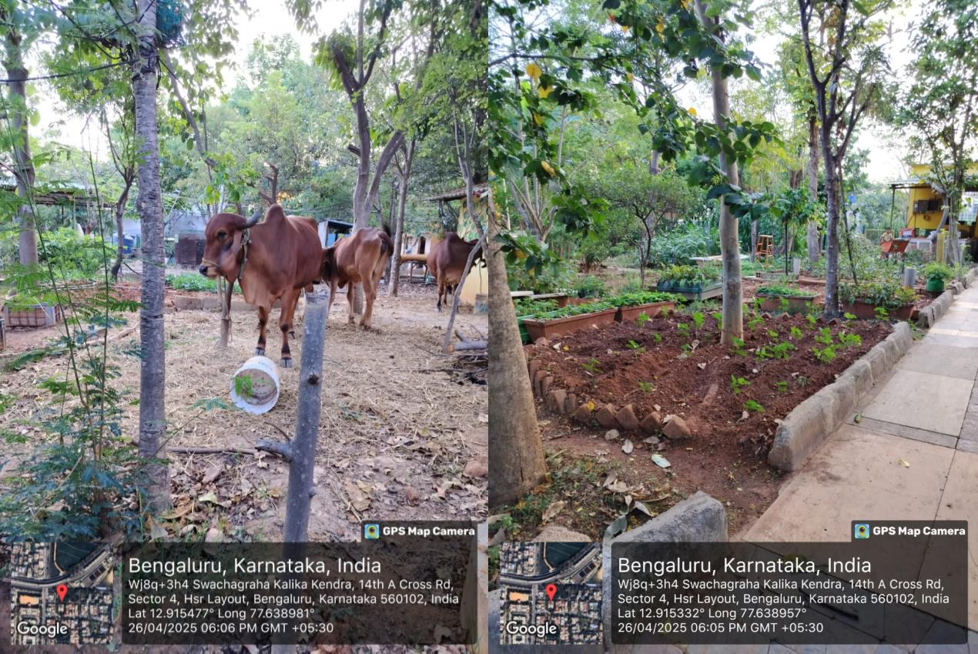

**WASTE MANAGEMENT:**

**INTRODUCTION:**

Waste management is the process of collecting, treating, and properly disposing of waste materials in a way that protects the environment and human health. It includes practices like recycling, composting, and safe disposal of waste to reduce pollution. Managing waste properly helps save natural resources, prevents land and water pollution, and supports a cleaner, healthier community. With growing population and urbanization, effective waste management has become more important than ever for building a sustainable future.

# OBJECTIVES:

* To reduce the amount of waste generated by promoting recycling, reusing, and composting practice.
* To promote sustainable use of resources by encouraging the recovery and reuse of materials.
* To improve public health and hygiene by managing waste in a clean and organized way.
* To create awareness among people about proper waste segregation (wet and dry waste) and its importance.
* To protect the environment by safely managing and disposing of waste to prevent land, air, and water pollution.

# VISIT:

As part of our activity, we visited Swachagraha Kalika Kendra, a center focused on organic farming and effective waste management practices. During the visit, we learned how wet waste (like food and garden waste) can be converted into compost using natural processes.

The center showed us different methods of waste segregation — separating wet waste and dry waste — and explained the importance of composting to reduce the amount of garbage sent to landfills. We observed compost pits, biogas units, and eco-friendly techniques for handling daily waste.

The visit helped us understand how simple actions like proper waste separation at home and in communities can contribute to a cleaner and greener environment. It also motivated us to think about how these methods can be implemented in nearby villages and our own campus.

# USES:

* Reduces Pollution: Proper waste management helps in reducing land, air, and water pollution.
* Conserves Natural Resources: Recycling and composting save resources like trees, water, and minerals.
* Promotes Clean and Healthy Environment: Managing waste properly keeps surroundings clean and improves public health.
* Produces Useful Products: Wet waste can be turned into compost and biogas, which are useful for farming and energy production.
* Reduces Waste in Landfills: By recycling and composting, the amount of garbage dumped in landfills is reduced.

# CASE STUDY:

In a residential community in Bangalore, a lot of wet waste from kitchens and gardens was being mixed with dry waste and sent to landfills. To solve this, the residents decided to start wet waste management inside their community.

They set up composting units where food waste, vegetable peels, and garden leaves were collected separately and turned into compost. The compost produced was then used in their community gardens to grow plants and vegetables.

The residents also organized awareness programs to teach families about the importance of waste segregation at home**.**

# OUTCOMES:

* Cleaner Environment: Proper waste management leads to cleaner streets, parks, and public places.
* Reduced Pollution: It helps in reducing soil, air, and water pollution caused by improper waste disposal.
* Better Public Health: Less waste means fewer breeding grounds for pests and diseases, improving community health.
* Resource Recovery: Useful materials like compost, recycled plastics, and metals are recovered from waste.
* Awareness Among People: People become more responsible about waste segregation and eco-friendly practices.

# CONCLUSION:

Waste management plays a vital role in keeping our environment clean and healthy. By properly segregating, recycling, and composting waste, we can reduce pollution and conserve natural resources. It not only improves public health but also promotes sustainable living for future generations. Small actions at individual and community levels can make a big difference**.**

**GEO tagged photos: (minimum 6 pics with group and individual)**

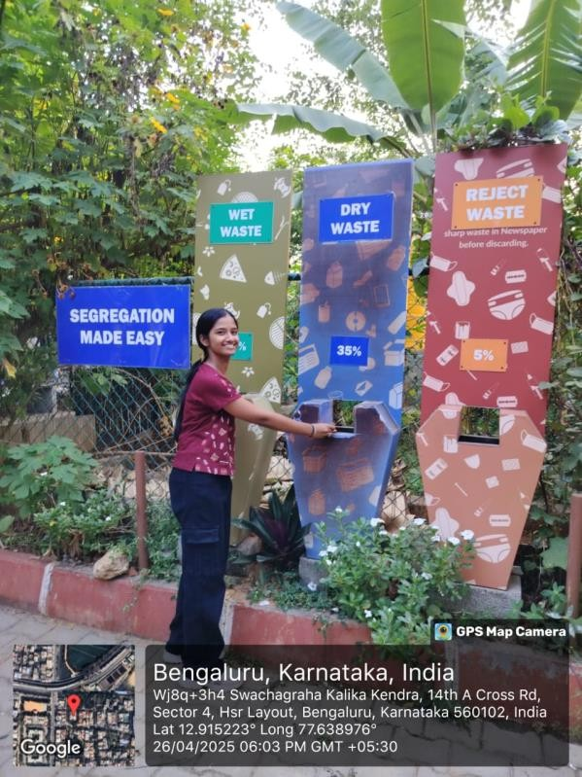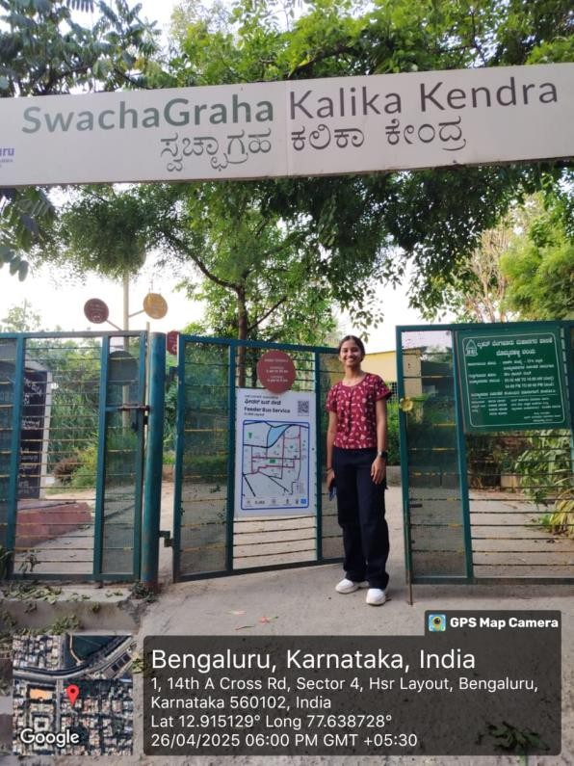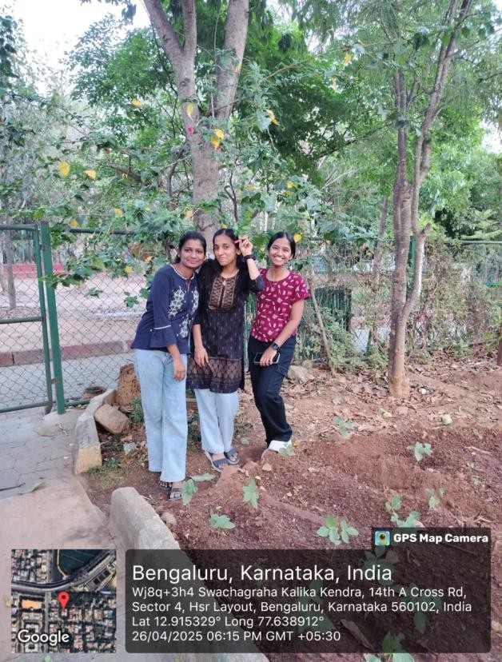

**Student Signature Faculty Mentor Signature**